

**Product Dissection for Flipkart**

### **Company Overview:**

Flipkart, founded in 2007 by Sachin Bansal and Binny Bansal, Flipkart has grown into one of India's leading e-commerce giants. Based in Bangalore, the company has transformed the way Indians shop online, offering a vast array of products ranging from electronics and fashion to home essentials and groceries. Acquired by Walmart in 2018, Flipkart continues to dominate the Indian online retail market, known for its user-friendly interface, extensive product range, and innovative initiatives like Flipkart Plus and SuperCoins. With a focus on customer satisfaction and seamless shopping experiences, Flipkart has become a household name, connecting millions of buyers and sellers in India's bustling online marketplace.

### **Product Dissection and Real-World Problems Solved by Flipkart:**

Flipkart is like a giant online store where you can buy all kinds of things, from clothes to gadgets, without leaving your home. It's designed to make your online shopping experience easy and enjoyable, just like having a helpful friend by your side.

One of the best things about Flipkart is how it helps you find exactly what you want. Imagine going to a huge mall with countless shops. It can be overwhelming, right? But with Flipkart, you don’t need to worry about getting lost in the shopping maze. It's like having a friend who knows your taste and shows you the coolest stuff tailored just for you.

Not only does Flipkart help you discover products, but it also makes sure you get them without any fuss. It handles the delivery part, ensuring your items reach your doorstep safely. And if, for any reason, you don't like what you ordered, Flipkart makes it super easy to return or exchange things, making sure you're always happy with your purchases.

Flipkart is not just a store; it's a community where people share their experiences. You can read what others think about products before you decide to buy, just like listening to your friends’ recommendations. This way, you can make smart choices and buy things that you’ll truly love.

In a nutshell, Flipkart is your friendly online shopping buddy, simplifying the shopping process, making it fun, and ensuring you always find what you need. It’s like having a knowledgeable friend who guides you through the world of endless choices, making your shopping journey delightful and stress-free.

### **Case Study: Real-World Problems and Flipkart’s Innovative Solutions**

Flipkart, a popular online store, has solved real-life problems through smart ideas. It changed how we shop by making it easy and fun. With Flipkart, finding things you love is simple, like having a helpful friend. It delivers what you buy to your door, making shopping stress-free. Flipkart also listens to what you like and shows you things you might want, making your shopping experience special.

**Problem 1: Finding the Right Products**

**Real-World Challenge:** Online shoppers often struggle to find the products they truly want amidst a vast array of choices, leading to frustration and confusion.

**Flipkart's Solution:** Flipkart understood this issue. It created a user-friendly platform where people can easily explore products. With clear categories, helpful filters, and easy search options, Flipkart ensures that customers find what they're looking for without any hassle, making online shopping a breeze.

**Problem 2: Too Many Options, Too Little Time**

**Real-World Challenge:** The internet is flooded with products, making it overwhelming for shoppers to pick the best one, especially when they're short on time.

**Flipkart's Solution:** Flipkart tackled this problem with its curated suggestions. By analyzing user preferences, Flipkart showcases products tailored to individual tastes. This way, customers are presented with a personalized selection, saving time and making the shopping experience enjoyable.

**Problem 3: Trust Issues with Online Shopping**

**Real-World Challenge:** People often worry about the authenticity of products and the reliability of online sellers, causing trust issues in online shopping.

**Flipkart's Solution:** Flipkart built trust through genuine customer reviews and reliable sellers. They established a system where buyers could leave feedback, creating a community-driven trust network. Additionally, Flipkart partners with trustworthy sellers, ensuring customers receive authentic products, eliminating trust concerns.

**Problem 4: Hassles in Returns and Exchanges**

**Real-World Challenge:** Returning or exchanging products purchased online can be cumbersome, deterring people from making online purchases.

**Flipkart's Solution:** Flipkart simplified this process. They introduced a hassle-free return policy, allowing customers to easily return or exchange products. This customer-friendly approach eliminated the worry associated with online shopping, providing a seamless experience and building trust among shoppers.

**Conclusion:**

### Flipkart has transformed online shopping. By making it easy to find products, offering personalized suggestions, and ensuring trust through genuine reviews and reliable sellers, Flipkart has solved common shopping worries. It's not just an online store; it's a trustworthy friend in the world of digital shopping. Flipkart's simple, user-friendly approach has made online shopping a breeze, earning it the trust and loyalty of millions.

### **Top Features of Flipkart:**

1. **Product Variety:** Flipkart offers a vast range of products, including electronics, fashion, home essentials, and more, providing customers with a diverse selection to choose from.
2. **User-Friendly Interface:** With a simple and intuitive design, Flipkart ensures easy navigation, allowing users to find products swiftly and efficiently.
3. **Search and Filters:** Flipkart's search functionality is robust, allowing users to search for specific products. Filters help refine searches based on price range, brand, ratings, and more, aiding in precise product discovery.
4. **Product Reviews:** Customers can read genuine product reviews and ratings from other buyers, providing valuable insights and aiding in informed decision-making.
5. **Secure Payments:** Flipkart ensures secure transactions through various payment options, including credit/debit cards, net banking, and cash on delivery, enhancing user trust and confidence.
6. **Wishlist:** Users can create wishlists, saving products for future purchase, making it convenient to keep track of desired items.
7. **Flipkart Plus:** A membership program offering benefits like faster delivery, early access to sales, and exclusive rewards, enhancing customer loyalty and satisfaction.
8. **Easy Returns:** Flipkart's hassle-free return policy allows users to return products easily, ensuring a seamless and worry-free shopping experience.

### **Schema Description:**

The schema for Flipkart's data schema comprises essential entities that define its operational structure:

**User Entity:**

Users are pivotal in Flipkart's ecosystem, represented by:

* **UserID (Primary Key):** A unique user identifier.
* **Username:** User's chosen identification.
* **Email:** User's email for communication.
* **Full Name:** User's complete name.
* **Address:** User's delivery location.
* **Mobile No:** Mobile no of user account creation.

**Product Entity:**

Products form the core of Flipkart's offerings:

* **ProductID (Primary Key):** Unique product identifier.
* **ProductName:** Name of the product.
* **Category:** Product category (electronics, fashion, etc.).
* **Price:** Product's cost.
* **Stock_Availability:** Quantity available in stock.

**Order Entity:**

Represents customer orders:

* **OrderID (Primary Key):** Unique order identifier.
* **UserID (Foreign Key Referencing User Entity):** User who placed the order.
* **ProductID (Foreign Key Referencing Product Entity):** Product included in the order.
* **Order_Date:** Date and time when the order was placed.
* **Delivery_Status:** Current status of the delivery (shipped, delivered, etc.).

**Review Entity:**

Customer feedback on products:

* **ReviewID (Primary Key):** Unique review identifier.
* **UserID (Foreign Key referencing User Entity):** User who wrote the review.
* **ProductID (Foreign Key referencing Product Entity):** Product being reviewed.
* **Rating:** Customer's rating for the product (1 to 5 stars).
* **Comments:** Textual feedback provided by the user.
* **Review_Date:** Date when the review was submitted.

**Payment Entity:**

Represents payment details:

* **PaymentID (Primary Key):** Unique payment identifier.
* **OrderID (Foreign Key referencing Order Entity):** Order for which the payment was made.
* **Payment_Method:** Method used for payment (credit card, cash on delivery, etc.).
* **Payment_Date:** Date and time of the payment transaction.

**Relationships are:**

**Users place Orders:** Each user can place multiple orders.

**Orders contain Products:** Each order consists of one or more products.

**Users write Reviews:** Users can provide feedback on multiple products.

**Products can have Reviews:** Products can be reviewed by multiple users.

**Orders involve Payments:** Each order requires a payment transaction**.**

**ER Diagram:**

Let's construct an ER diagram that vividly portrays the relationships and attributes of the entities within the Flipkart schema. This ER diagram will serve as a visual representation, shedding light on the pivotal components of Flipkart’s data model. By employing this diagram, you'll gain a clearer grasp of the intricate interactions and connections that define the platform's dynamics.

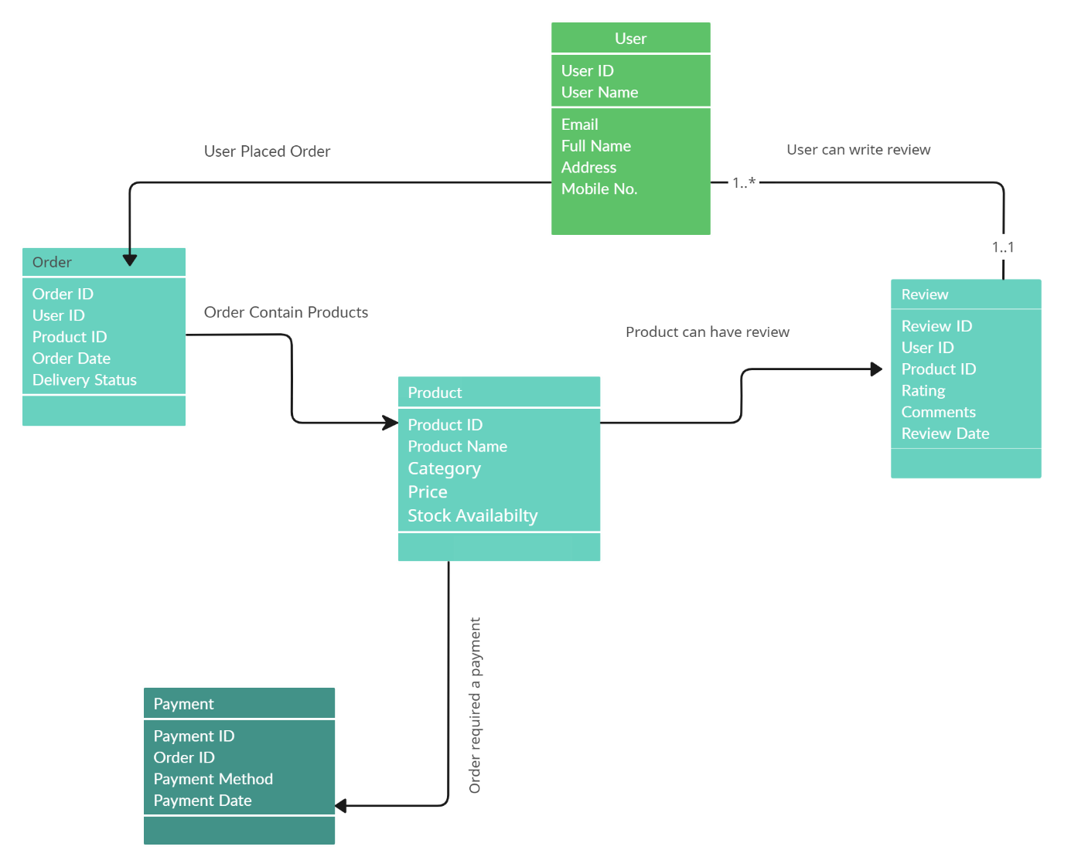

### **Conclusion**

In this case study, we explored the intricacies of Flipkart's schema and Entity-Relationship diagram. Flipkart has transformed the e-commerce landscape, providing users with a seamless platform for shopping and transactions. Its sophisticated data model includes entities such as users, products, orders, reviews, and payments, forming the backbone of its efficient functionality. Understanding this schema provides valuable insights into how Flipkart manages user interactions, product inventory, and financial transactions, contributing to its widespread success in the realm of online retail. Flipkart's innovative approach to e-commerce has revolutionized the way people shop, fostering convenience and reliability in the digital marketplace.